WEEK2

TO DEMONSTRATE QUEUES USING ARRAYS

STUTI UNIYAL

1BM21CS220

#include<stdio.h>

#include<conio.h>

#include<stdlib.h>

#define SIZE 3

int queue[SIZE],rear=-1,front=0,ITEM;

void push();

void pop();

void display();

void main()

{ int choice;

while(1)

{

printf("\n\n 1:push\n 2:pop\n 3:display\n 4:exit\n");

printf("enter your choice");

scanf("%d",&choice);

switch(choice)

{

case 1:push();

break;

case 2: pop();

break;

case 3: display();

break;

case 4: exit(0);

break;

default: printf("wrong choice");

}

}

getch();

}

void push()

{

if(rear==SIZE-1)

{

printf("queue is full");

}

else

{

printf("enter an element\n");

scanf("%d",&ITEM);

printf("entered element is %d\n\n",ITEM);

rear++;

queue[rear]=ITEM;

}

}

void pop()

{

int del;

if(rear==-1)

printf("queue is empty\n");

else

{

del=queue[front];

front++;

if(front==SIZE)

{

front=0;

rear=-1;

}

}

}

void display()

{

int i;

if(rear==-1)

{

printf("QUEUE IS EMPTY\n");

}

else

{

for(i=front;i<=rear;i++)

{

printf("%d\n",queue[i]);

}

}

}

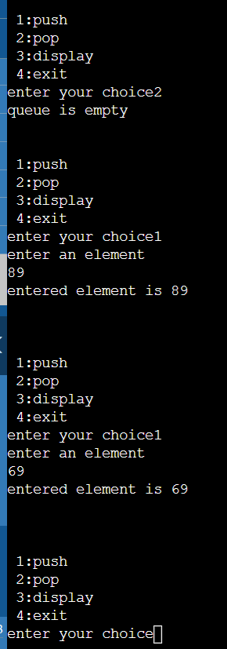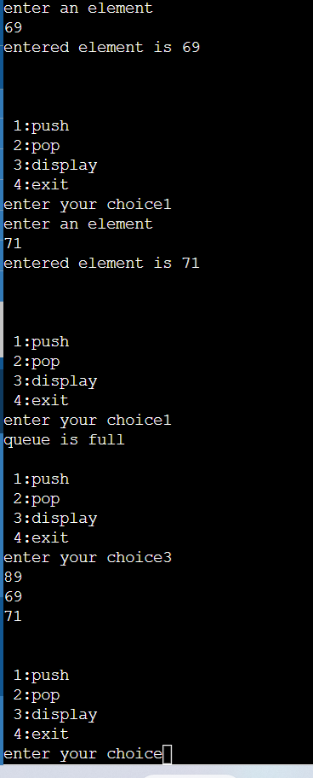SNAPSHOTS OF OUTPUT